Design and Control of a Cable Driven Snake Robot: Supplementary Material

**Sec. I: Proof of the claim in Sec. IV-A**

**(Derivation of a closed form approximation for the phase offset that maximizes the forward speed of a snake robot)**

Liljebäck et al. [5] showed that *δ*opt, the *δ* that maximizes the speed of a snake robot (in a simplified dynamic model) during serpentine locomotion is given by the *δ* that maximizes

, (1)

where *cij* is the *ij*th entry of ℝ(*N*–1)×(*N*–1), with ℝ*N*×(*N*–1) and , ℝ(*N*–1)×*N*, the so called *addition* and *difference* matrices.

We obtain a closed form approximation of *δ* as a function of *N* by deriving some properties of . First of all, we define , to clean up the notation. We also define the matrix  ℝ*n*×*n*, with *ij*th element *bij*. Note that since a matrix times its transpose is symmetric, and the inverse of a symmetric matrix is also symmetric,  is symmetric. We will need the following:

**Prop. 1.** The sum of the *k*th diagonal of ℝ*n*×*n* is , where *Tk* is the *k*th tetrahedral number .

Note that by the *k*th diagonal, we mean counting from the bottom left or top right corner of a matrix and moving toward the main diagonal. For example, a **B** matrix of dimension *n*=4, with each of the diagonals marked with its own bracket style, could be represented as:. To prove Prop. 1, we will need to show three things:

* 1. The lower left element and the top right element of **B** are both , and the rows and columns increases sequentially in units of  as we move left along the top row, right along the bottom row, up along the leftmost column, or down along the rightmost column, as shown above for the case *n* = 4.
  2. The first *n* diagonals (starting at the bottom left corner) of a **B** matrix of dimension *n* are precisely the diagonals of all of its lower dimensional counterparts, scaled by .
  3. The sum of the main diagonal of  is .

To prove 1.1., note that for the first column of **B**,  and . That the first column increases sequentially by factors of *bn*,1 from the *n*th element to the first can be proved by induction on the *i*th element from the end, with base case  (We’ve already shown cases  and , and case  is true by definition). Namely, suppose  for some . Then, , which proves the claim. Reaching the first element, we have . Applying the same argument to the last column of **B** shows that its elements increase in units of  from the top right corner to the lower right corner. Thus, since the matrix is symmetric, the top and bottom rows increase in the same way: right to left along the top row and left to right along the bottom row.

For 1.2., notice that the *i*th element on the *k*th diagonal,  (where  and ), is recursively generated by the two elements directly under it according to the rule  until we get to the second to bottom row, where . Thus, the first *n* diagonals of **B** are generated from the bottom row in the same manner for a **B** matrix of any dimension, and differ only by the bottom row’s scaling factor of .

Now for 1.3. Here  is the so called “second difference matrix,” in which, by definition, the sum of the *k*th lower diagonal, moving from the bottom left toward the main diagonal, is . Since ℝ*n*×*n* , , and since is symmetric, we can write  for the main diagonal. So, the difference of the sums of the inmost two diagonals is related to the dimension of the matrix. Define  as the sum of the *k*th diagonal in an *n*-dimensional **B** matrix, moving from the outside in. Then, for the case , the difference of the sums of the inner two adjacent diagonals is given by the recursion relation , which we recognize as.

We can now prove by inverse induction on *n* that the *k*th diagonal of a **B** matrix of dimension *n* sums to . This is clearly the case for or . For , the sum of the main diagonal is  , and the sums of the outer diagonals are all given by  by 1.3, provided that the claim holds for all , which is true by the induction hypothesis. This proves the lemma.

Now, multiplying  from the left by the transpose difference matrix  has the effect of subtracting adjacent diagonals, from the top right to the bottom left. In other words, the sum of the *k*th diagonal for some  becomes . Thus, the sum of the *k*th diagonal in the upper triangle of becomes  and the lower triangle is just the negative of this. But  is just the *k*th triangular number . So to summarize, the sum of the *k*th diagonal of a  matrix of dimension (*n*–1)×*n* is , where the plus sign corresponds to the diagonals in ’s upper triangle and the minus sign to those in the lower triangle.

We now show that the diagonals of  sum to , except for the main diagonal, where the plus sign again corresponds to the diagonals in the upper triangle and the minus sign to those in the lower triangle. We will do this by looking separately at the upper and lower triangles of , where **M** is an arbitrary matrix of dimension (*n*–1)×*n*. First note that left-side multiplication by the **A** matrix adds each row of **M** to the one above it, and the bottom row is cut off. But in the lower triangle of **M**, moving an element up by one row also moves it up by one diagonal, so an alternate way of viewing left-multiplication by **A** is that each diagonal is added to the one above it for , and the element belonging to the first row of **M** is removed. But as we have already shown, the element of the *k*th diagonal of the lower triangle of **M** that belongs to **M**’s bottom row is just *k*. So, denoting the sum of the *k*th diagonal in the lower triangles of **N** and **M** as *nk* and *mk*, respectively, . But the recursion relation for the triangular sequence is just , so . The situation for the upper triangle is exactly the same, except that the element which is removed from the *k*th diagonal of **M** is the one that belongs to **M**’s top row, and as we have shown, the element of the *k*th diagonal of the upper triangle of **M** that belongs to **M**’s top row is *k*. Thus, the sum of the *k*th diagonal of **N** is twice the sum of the *k*th diagonal of **M**, except for the middle diagonal. We summarize these facts in the following result:

**Prop. 2.** The *k*th diagonal of **C** sums to .

Given this fact about **C**, we can now simplify the double sum . Since the definition of the *k*th diagonal is that *j*–*i* = *k*, for some 0 < *k* < *N*–1, the sine term is unchanged along each diagonal, and its sign flips exactly when **C**’s sign flips. Thus, we can change *kδ* to a sum over the diagonals: . Plugging in *N*–1 for *n*, we arrive at the following:

**Prop. 3.**  (2)

We can expand the summation:



Taking a derivative with respect to *δ*, and setting the result equal to zero,



$\frac{1+N\left(N–1\right)}{N+1}cos⁡(\overline{δ})+\frac{N–2}{N+1}\cos\left(\overline{δ}N\right)=\cos\left(\overline{δ}\left(N–1\right)\right)+N–2$ (3)

(Note that for *N* = {1, 2}, this equation is satisfied for all $\overline{δ}$.) Taylor expanding (3) to second order at $\overline{δ}=0$ and solving, $\overline{δ}≈\sqrt{\frac{30}{3N^{2}-3N+2}}$. Expanding (3) to fourth order at $\overline{δ}=0$,

$$\overline{δ}≈2Re\left(\sqrt{\frac{21N\left(N-1\right)+\sqrt{-84N\left(N-1\right)\left[N\left(N-1\right)+3\right]-119}+14}{\left[N\left(N-1\right)+1\right]\left[5N\left(N-1\right)+3\right]}}\right)$$

Expanding to second order at $N=∞$,

$\overline{δ}≈2\sqrt{\frac{21}{5}}\frac{1}{N}+2.14698\frac{1}{N^{2}}≈4.10/N+2.15/N^{2}$ (4)

This last expression approximates the exact solution to within 2.75% error for all $3≤N≤100$.

Figure 1 compares a numerical computation of the exact result in (2) with the approximation given by (4).

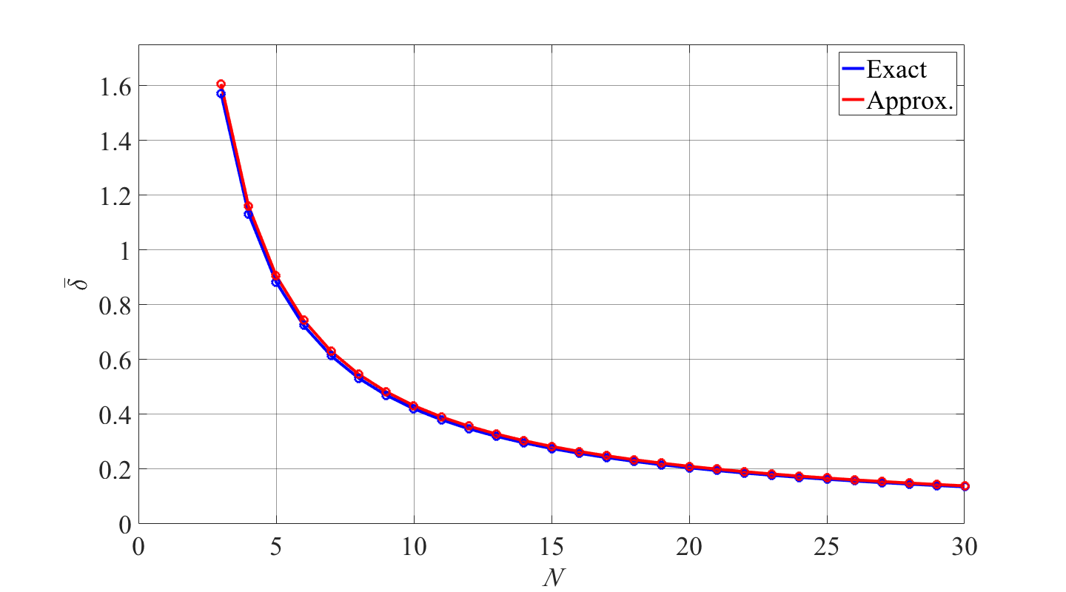

*Fig. 1. Comparison of expressions for $\overline{δ}$, given by (2) (Exact) and (4) (Approx.), for N = 3 to 30.*

References

[1] P. Liljebäck, K. Pettersen, Ø. Stavdahl, and J. Gravdahl, *Snake Robots: Modeling, Mechatronics, and Control.* London, UK: Springer, 2013.

**Sec. II: Derivation of Eq. (9)**

We write the joint dynamics as:

$$\ddot{ϕ}\left(t\right)=\frac{1}{I}\left(\left[k_{p}α\sin\left(ωt+ε\right)+k_{d}αω\cos\left(ωt+ε\right)\right]-bϕ\left(t\right)-c\dot{ϕ}\left(t\right)\right)$$

where $b=k_{p}$ and ${c=k}_{d}$. Recall that $I=\frac{1}{12}mL^{2}$ is the link moment of inertia for a link of mass *m* and length *L*; $k_{p}$ and $k_{d}$ are PD gains; *α*, *ω* are control parameters defined in Eq. (4); and $ε$ is an arbitrary offset.

Solving with Wolfram Mathematica, with $ϕ\left(0\right)=0$ and $\dot{ϕ}\left(0\right)=0$, $ϕ\left(t\right)≈ϕ_{s}\left(t\right)+ϕ_{t}\left(t\right)$, where, $ϕ_{s}\left(t\right)=-\frac{αω\left(k_{d}Iω^{2}-bk_{d}+bc\right)}{{\left(Iω^{2}-b\right)}^{2}+c^{2}ω^{2}}\cos\left(ωt\right)$ is a steady-state term, and $ϕ_{t}\left(t\right)$ is a transient term.

Taylor expanding to second order in *ω* at $ω=∞$:

$$ϕ_{t}\left(t\right)≈\frac{α}{2Iω\sqrt{c^{2} –4bI} }\left\{\begin{matrix} \\ \end{matrix}\right.$$

$$\left[\left(ck_{d}-2{Ik}_{p}+k_{d}\sqrt{c^{2} –4bI}\right)\cos{(ε)}+2k_{d}Iω\sin\left(ε\right)\right]e^{-\frac{1}{2I}\left(c + \sqrt{c^{2} – 4bI} \right)t}$$

$+\left[\left(k_{d}\sqrt{c^{2} –4bI}+2{Ik}_{p}-ck_{d}\right)\cos{(ε)}-2k_{d}Iω\sin\left(ε\right)\right]\left.e^{-\frac{c}{2I}t}\right\}$.

**Sec. III: Elaboration on the claim in Sec. IV-A**

We now show that doubling the number of links in a convex polygonal linkage with fixed joint angular displacement ratios always improves the fit of the linkage to a convex section of a sinusoid, and that this continues to hold as the amplitude and wavelength of the sinusoid are changed, provided that the sinusoid has invariant arc length. Suppose that a half-period of a sinusoid (starting and ending at an inflection point) is fit by a two-link linkage whose first and last points coincide with the first and last points of the sinusoid, and which lies completely underneath it (the argument for fitting from above is similar). Call this step 1; at step *n* we will form an approximation using a convex linkage with 2*n* links and interior angles with fixed ratios. At step *n*, draw two equal links for each link in step *n*–1, each ending on the joints from step *n*–1. Also, require that each such link pair has a total length greater than the length of the link that they replace, but also that the sum of all link lengths at any step is less than the total arc length of the sinusoid (this is always possible). By the triangle inequality, each such link pair will always lie between the link of the previous step and the sinusoid. In the limit that *n* goes to infinity, the total length of the linkage will equal the arc length of the sinusoid and we have the case of a continuous snake. Now imagine that the endpoints of the convex linkages are made to slide away from each other along the line intersecting their endpoints. Since the total length of a more articulated linkage in this arrangement is always more than that of a less articulated linkage, the endpoints of the more articulated linkage will always be further apart than those of the less articulated linkage. Furthermore, the more articulated linkage will always continue to enclose the less articulated linkage, since to do otherwise would require that it violate its convexity. A convex curve is the limiting case, and since a half-period of a sinusoid is convex, it will always enclose a convex linkage fit from below, and every point on a more articulated linkage fit by the above procedure will always lie between the sinusoid and every point on a less articulated linkage.

We here show bounds on how well *N* uncoupled links can approximate a half period of a static sine wave, in terms of the difference in the areas enclosed by the curves and the line joining their endpoints, which we denote by *ε*Area. To compute a lower bound, imagine a procedure in which at step *j* we fit *j* links of length *Sj*/*j*, where *Sj* is the length of the full mechanism in that step and is no more than the arc length of the sine curve. In the *j*th step, define *δi*,*j* as the distance from joint *i* of the linkage to the sinusoid along the perpendicular bisector of joints *i*–1 and *i* +1. The area-error at this step is no greater than the area of the triangle formed by links *i* and *i* +1 and the line joining joints *i*–1 and *i* +1, which is less than or equal to *δi*,*jL* (this only works because of the convexity of sine over a half-period). So the area-error is  where *δi*,*j*,max is the maximum *δi*,*j* for this step.In the following step, we subdivide the triangular region into two sub-triangles formed by the intersection of the old perpendicular bisector with the sinusoid and the links from the previous step, with new links half the length of the previous step. This is always possible. In this step, *δi*,*j*2 = (*L*/2)2–(*L*2–*δi*,*j*–12)/4, so *δi*,*j* *=* *δi*,*j*–1/2 and thus *δi*,*j* ∝ 1/(2*j*+1) = 1/(*N*+1). Thus, .

On the other hand, the area under a half-period of a sine wave can be approximated by evaluating sine at each of *Nd* +1 equally separated points on the *x*-axis and calculating the area *PA* of the resulting polygon:

. We can insure that this approximation for the area under the sine curve is at least as good as the optimal linkage fit by ensuring that the projection onto the *x*-axis of the smallest interval *x*min in the optimal fit is no less than *λ*/(4*Nd*). But *x*min ≥ *L*cos(*θ*max) = *λ*/(4*N*)cos[arctan(2π*A*/*λ*)] = *λ*/(4*N*)[(2π*A*/*λ*)2+1]–1/2 , so we can set . The area error from a fit by an *N*-link linkage is then .

In summary, we’ve established that the area-error of the linkage is *O*(1/*N*) and *Ω*(1/*N*2).